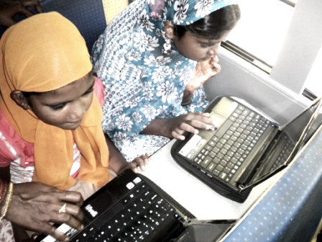
How KarmaCompany can help your project
Part 4:
Part 5:
What to expect next
Part 3:
About your project
Undoubtedly the lengthiest part of the application, filled with (what we hope are) thought-provoking questions about your project, and what you’re trying to achieve.
Part 2:
Project overview
Budget, area of focus, duration
  - Before filling out this application, please review our project facilitation FAQs found on our website
Organization’s mission:

Years in existence:

Number of staff members:

Part 1: General Information
Your Name:

Your organization:

Head of organization:

Your role in organization:

Phone number: | E-mail address:
City: | Website address:
State: | Best time to contact you:
Country: | Fax Number:

KarmaCompany Project Facilitation Application
Applicant Checklist
General Information
The basics, contact information, etc
Part 1:
Fusce mollis tempus felis.

+

Part 3: About Your Project: Please write in paragraphs, not lists
Part 2: Project Overview:
+
What activities are to be conducted, and how will they be carried out?
What are the program objectives? How does the program benefit society?
Area of focus: place an “x:” next to a category below:
Agriculture Animal Rights Community Education Health Women’s Empowerment
Project Title
Project Duration (start and completion dates)
Project Budget:*

*Note: The receiving organization should not expect money as part of our project facilitation program. As such, we expect the organization to secure at least 75 percent of its funding before seeking our assistance. KarmaCompany may offer funding to improve the project, or to maximize its impact through the purchase of additional resources. We are not, however, liable to issue such funding, nor should it be expected. If requiring money to create and execute your project, please seek a KarmaGrant or a KarmaLoan instead.

Who are the project beneficiaries (direct and indirect)?

How will you target these beneficiaries, and what are the incentives to take advantage of the project’s offerings?

Have you or another organization done this project before, or one of a similar nature? If so, when?

What resources will be utilized for project implementation (for ex. Number of volunteers, staff, hired labor, equipment, materials, etc)?
What are the project’s biggest obstacles, and how does the organization anticipate overcoming them?:

Please detail the project’s accountability procedures (meetings, check-ins, reports, expected correspondence, etc.):

How does your organization plan on promoting the project? What is your organization’s current social network outreach figures (ie, number of Facebook supporters, no. of Twitter followers, etc.)?:

Can the program be replicated and scaled?
- sodales.
Etiam eu ipsum. Donec ac arcu.
Lorem ipsum dolor sit amet, consectetuer adipiscing elit. Vivamus semper sodales lorem. Quisque venenatis vehicula lectus. Donec a odio eu eros lobortis vehicula.
Part 4: How KarmaCompany can help your project
What kind of assistance are you seeking from KarmaCompany? Please be as specific as possible:

How will KarmaCompany’s facilitation help with the creation and/or implementation of your project?:
In return for our assistance, is your organization willing to share information regarding the project’s creation, implementation and the techniques utilized?:

Do you have a point person in the organization who is willing to provide pictures, exchange emails and/or capture videos throughout the project?


Thank you for your interest in getting KarmaCompany involved with your project.
- Please email this application to sriram@karmacompany.org

- Expect a response from us in 30 days. If for some reason the application has disappeared into the abyss of our inboxes and you fail to hear back, send us a follow-up. We know you took the time to fill out this application, so it’s only fair for us to write back with a ‘yes’ or ‘no’ decision.

- If we are interested in facilitating this project with your organization, the next step is discussing the project in greater detail with the person responsible for orchestrating the project, and that person’s direct supervisor.

- If KarmaCompany declines to collaborate on this particular project, this doesn’t prevent your organization from applying for grants, loans, or project facilitation on a different project in the future.

Best of luck, from our organization to yours!

Email:
sriram@karmacompany.org

Address:
﻿Flat 2, Ground Floor, La Serena
Ceebros, 12 Sterling Road
Second Cross St
Nungambakkam Chennai 600034
Tamil Nadu, India

+
KarmaCompany
Part 5: What to expect next
Issue | Date
Lorem Ipsum

